
Flexible working self-assessment tool for Multi-Academy Trusts and Schools

Flexible Working Self-assessment Tool for MATs and Schools

This tool will support leaders to assess their current flexible working arrangements and provide ideas for next steps to further develop their practice. It shows steps to take for those starting out on their journey and more advanced steps to help leaders embed a culture of flexible working. All of these things are important in helping a school work towards a strong flexible working culture. This tool is voluntary and can be used internally to develop your flexible working practices.
Strategic areas for consideration:

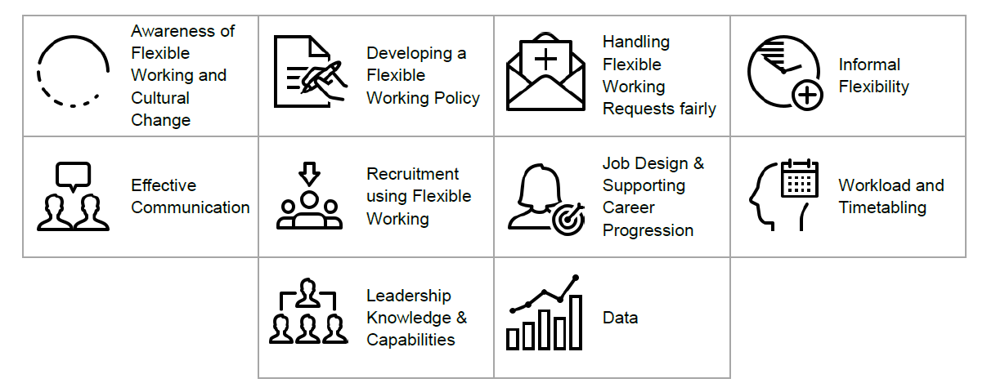

Strategic area for consideration | Beginning your journey/developing your practice | Embedding a flexible working culture
Awareness of flexible working and cultural change | - Learn about the range of flexible working practices and the benefits they can bring in schools.  - Nominate a Flexible Champion to promote/attend webinar/workshop training sessions.  - Promote benefits of flexible working to the school community including governors/trustees. | - Team of SLT members model flexible working practices and attend webinars to develop understanding.  - Staff surveys carried out to assess impact/staff perceptions of flexible working.  - Flexible working celebrated as part of school’s people strategy and values.  - Contribute to wider thought leadership in the sector – promote case studies in local networks.
Supporting resources:
- DfE Toolkit Resource - ‘Implementing Flexible Working’
- Webinar: The benefits of flexible working in alternative provision
- Webinar: Communicating the benefits of flexible working to stakeholders within a SEND school environment
- Webinar: Making flexible working work across different school settings

Flexible Working Policy | - School has a flexible working policy in place, regularly updated in line with relevant legislation and Acas guidance.  - Policy includes a definition of flexible working including range of formal and informal arrangements, eligibility, details on making a flexible working request and right to appeal.  - All staff are aware of and understand the flexible working policy.  - Policy proactively shared with all staff, particularly at key times such as during parental leave or extended sickness absence. | - Staff and trade unions have been consulted when developing the policy.  - Policy goes above and beyond legal requirements and is positive about flexible working. Includes information about how it supports the school ethos.  - Staff are surveyed to gauge how well they understand the policy.  - Policy reviewed on an annual basis in collaboration with staff.
Supporting resources:
- DfE Flexible Working Toolkit Resource - Example Flexible Working Policy
- Flexible working policy template | Acas
- Flexible working legislation FAQs
- Flexible working in schools – guidance
- Flexible job design: how to make flexible working the default

Flexible working requests | - Process for requesting flexible working set out clearly in the flexible working policy.  - Requests are dealt with appropriately as set out in Acas Code of Practice and school adopts a ‘reason neutral’ approach to requests, considering all requests equitably.  - Individuals are encouraged to discuss flexible working requests openly and informally in advance of an application being made.  - Staff are encouraged to seek advice and support from their union when making flexible working requests and are provided with tools to support formal requests, such as a pro-forma.  - Opportunities for staff to trial flexible working arrangements informally before committing to them contractually. | - Proactive ‘whole school’ approach adopted. All staff are asked about their flexible needs annually and these are included as part of the timetabling process.  - Survey in place to gauge how confident staff feel about making a flexible working request including whether they think it will be considered fairly, and whether it will impact their career progress. Survey results analysed and improvements made where needed.  - Middle leaders involved in discussing flexible working options with their teams.
Supporting resources:
- DfE Flexible Working Toolkit Resource - ‘Review a statutory flexible working request’
- Webinar: Making a Flexible Working Request
- Acas Code of Practice on handling flexible working requests | Acas
- DfE Flexible Working Toolkit Resource - 'Make a statutory flexible working request'
- DfE Flexible Working Toolkit Resource - 'Step by step guide showing how to submit and manage flexible working requests'

Informal flexibility | - Opportunities for informal flexibility considered and introduced e.g., off site PPA where appropriate, occasional personal days. | - Opportunities for informal flexibility embedded and celebrated as part of school’s flexible working culture.
Communication | - All staff communications are in a simple, weekly format to ensure that staff receive key information, and nothing is ‘missed’ by staff who work flexibly.  - Opportunities for remote meetings offered where appropriate.  - Clear expectations set for job-share teachers, who are allocated appropriate time for handover.  - If meetings take place on an individual’s non-working day, they are invited with no obligation to attend, as set out in the STPCD.  - If meetings take place when a member of staff is not on site, they are recorded, and staff are given the appropriate opportunity to catch up. | - Meetings planned around staff working flexibly.  - Parents receive proactive communication about school’s approach to flexible working and how this supports both staff and pupils.
Supporting resources:
- School teachers' pay and conditions - GOV.UK

Recruitment | - Some roles are advertised as part-time or with flexible working options highlighted.  - Adverts highlight that applications are welcomed from those seeking to work flexibly and invitations to discuss flexible working included.  - Where possible, platforms which have a ‘flexible working’ search function are used, such as the free DfE Teaching Vacancies site. | - Flexible working highlighted in all job adverts.  - School’s positive culture of flexible working celebrated as part of job advertisements.
Supporting resources:
- https://workingfamilies.org.uk/employers/happy-to-talk-flexible-working/Find a job in teaching - Teaching Vacancies - GOV.UK (teaching-vacancies.service.gov.uk)
- Webinar: Using flexible working to attract and retain local talent (particularly in areas that experience a high level of disadvantage)

Job design and supporting career progression | - Flexible working arrangements are available and accessible to those with a TLR.  - Flexibility considered when creating new roles.  - Clear information relating to pro rata requirements for directed time for those that work part-time, as set out in the STPCD.  - There is a process in place to support individuals to reach mutual agreement about arrangements for attending events such as INSET or parents’ evening when these fall on their non-contracted day (e.g., attendance not mandatory, or is compensated with time off in lieu.) | - Staff at all levels, including leadership are working flexibly and role modelling how flexible working supports career progression.  - Innovative staffing solutions are found based on the vision and values of the specific school setting.  - Staff working flexibly are offered specific support with career progression e.g., they are booked onto Flex Your Way to the Top webinar.  - Training available for staff on the types of flexible working, thereby raising awareness and understanding e.g., via staff meetings.
Supporting resources:
- School teachers' pay and conditions - GOV.UK
- Webinar: Flexible Job Design: how to make flexible working the default
- Webinar: Effective Job-Sharing for Primary and Secondary Teachers and Leaders

Workload and timetabling | - Workload impact assessments undertaken concerning workload management for those working part-time.  - Senior and middle leaders are conscious of sharing tasks out equitably for those working flexibly and part-time.  - Flexible working patterns are proactively considered as part of the timetabling process.  - Timetabling of PPA considers opportunities for flexibility, for example opportunity for off-site working considered where appropriate. | - Annual process of discussing flexible working embedded in the cycle of performance reviews.  - Strategic timetabling in place which balances needs of the school with staffing requirements, produced in consultation with staff.  - SLT carefully, strategically, and proactively monitor the workload of staff working flexibly.
Supporting resources:
- Home - Improve workload and wellbeing for school staff
- Webinar: Smarter Timetabling to Support Flexible Working

Leadership knowledge and capabilities | - Senior team aware of how flexible working might assist with recruitment and retention of all teachers, especially those at risk of leaving the profession.  - Senior team aware of the groups of teachers most at risk of leaving the profession (retirees, women aged 30-39 and teachers under 5 years of experience).  - Senior team aware of the national conversation about the gender pay gap and how lack of access to flexible working contributes to this gap in the education sector.  - Senior team knowledgeable about the STPCD guidance for directed time of those working flexibly (e.g., staff are not required to attend any events on a day which is not their contracted work day).  - Leadership team understand the wording of the STPCD regarding part-time TLR holders and are mindful of ensuring directed time is reduced proportionately for those working part-time. | - Ensure a member of the governing body engages with improving the flexible working offer within school.  - Regular and up to date training is provided for SLT and MLs on flexible working best practice.  - A member of the leadership team (Flexible Champion) is responsible for improving the flexible working offer within the school.
Supporting resources:
- Webinar: Flexible working: helping to recruit and retain staff
- Webinar: Using flexible working to attract and retain local talent (particularly in areas that experience a high level of disadvantage)
- Webinar: Leading flex for HR and school business managers - recording
Data | Data collected on:  - Types of arrangements already in place. This should include opportunities for informal flexible working, such as time off site for: Planning, Preparation and Assessment.  - Reasons for flexible working – this enables you to identify whether arrangements are limited to a narrow group and can help you to broaden requests for flexible working, promoting equality and diversity in your school.  - How many staff would like to work flexibly and what kind of arrangements they are interested in, including ad-hoc arrangements such as a family or personal day.  - How staff feel requests for flexibility are received by leaders.  - What staff perceive the impact of flexible working to be, including of leaders working flexibly. | - Analysis carried out to understand the range of formal and informal flexible working arrangements, what is working well and where schools can go further.  - Exit interviews take place for all staff through an appropriate/neutral channel. Information from these interviews is collated and used to improve staff experience.
Supporting resources:
- DfE Flexible Working Toolkit Resource - ‘Implementing flexible working'
- Webinar: Leading Flex for HR and School Business Managers

